



WHAT: The Eighth Annual Abelon Memorial Walk
WHEN: Saturday, May 18, 2013

Please join us as we honor the memory of Mr. Michael Abelon. Mr. Abelon was a highly respected science educator at East Hartford High School and a cofounder of the Connecticut IB Academy (CIBA), a magnet school in East Hartford that serves grade 9-12. He was a beloved teacher and principal, and he will always be remembered for the way he brought energy and confidence to the CIBA family. This May, the Student Advisory Board (SAB) will hold the Eighth Annual Abelon Memorial Walk in his memory to honor all of the hard work and care that he put into developing our school and educating our community with the support of the Michael Abelon Memorial Foundation, Inc. The proceeds from the walk will be split between The Pancreatic Cancer Action Network and the Michael Abelon Memorial Foundation, Inc which funds an annual scholarship for a graduating CIBA student.
The goals of this event are to help raise awareness about the alarming statistics that surround pancreatic cancer, as well as to support academic excellence. Pancreatic cancer has the highest mortality rate of all major cancers. 94% of pancreatic cancer patients will die within five years of diagnosis. 74% of patients die within the first year of diagnosis. Pancreatic cancer is a leading cause of cancer death largely because there are no detection tools to diagnose the disease in its early stages when surgical removal of the tumor is still possible. The National Cancer Institute (NCI) spent an estimated $97.1 million on pancreatic cancer research in 2010. This represented a mere 2% of the NCI's approximate $5 billion cancer research budget for that year.
The Pancreatic Cancer Action Network is a 501c3 non- profit organization founded in 1999, aimed at researching and developing treatments of pancreatic cancer in an effort to find a cure for the disease. They work with groups and organizations to sponsor walks in different areas around the United States. These walks raise money for pancreatic cancer research, programs, and patient services. The Michael Abelon Memorial Foundation, Inc is a 501c3 non-profit organization founded in 2010, which supports higher education through an annual scholarship awarded to a deserving graduating CIBA senior who best exemplifies the values and qualities that Mr. Abelon wished to instill in each and every student.

By partnering with the CIBA SAB in this walk, you will be helping the Pancreatic Cancer Action Network to accomplish their goals and supporting the Michael Abelon Memorial Foundation, Inc. We appreciate all donations that you are able to make. In addition, on the day of the event we host a prize drawing (artwork, gift certificates, jewelry, etc) and a basket drawing with themed baskets (Off to College Basket, Purple Pride basket, etc). If you would like to donate an item for this drawing, please mail to or drop off at Connecticut IB Academy, 857 Forbes Street, East Hartford, CT 06118 prior to the walk date.

Donations can be received up until the day of the walk, May 18^{h}, 2013. Bring money to the walk or visit our website at www.walkforabelon.com to donate securely online using PayPal.

Thank you in advance for your contributions and support,

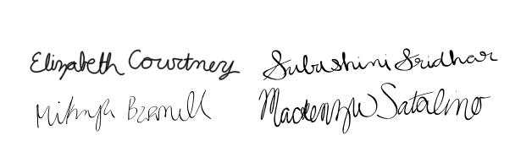

Rachel Buck
Abelon Memorial Walk Committee CIBA SAB Faculty Advisor

Contact us: mabelonmf@gmail.com

